**DIVISION 15 PICNIC IN THE PARK**

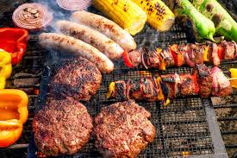

**Date:** Saturday July 26th

**Time:** Noon- 5 PM

**Place:** Brady Park

**Price:** $20 per person

Kids under 16 are free!

Please join your brother and sister Hibernians for this annual event. Bring your family and friends, all are welcome! Paid admission includes food (Hot Dog and Hamburgers, Sausage and Peppers, corn on the cob) beer and soda

We will also have our annual horseshoe tournament.

And as always, we will be holding a 50/50 raffle

Please see Dennis or Warren for tickets and more information

