***Join your fellow Hibernians as we cheer on Long Islands own NY Fighting Tomcats as they play the Hartford FC.***

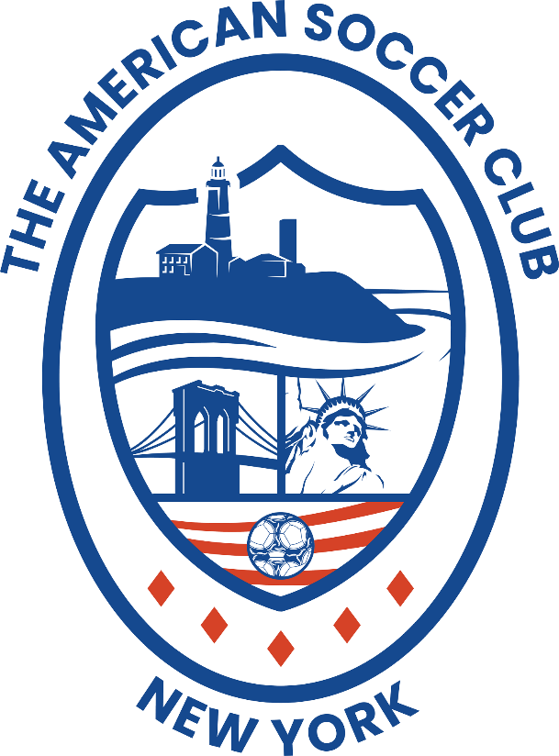

Date- Tuesday June 24th

Time- 7:00PM

Place- Captains Field- Hofstra University

Tickets- $14.00

See Dennis for details